**THERMISTOR BASED TEMPERATURE CONTROL**

**ABSTRACT:**

The project is designed to develop a temperature control system using a thermistor. It is helpful to maintain a constant temperature of an enclosed area.

Whenever temperature increases beyond a certain value, a lamp (indicating a cooler) is switched on to bring the temperature to normal value. As switching ON of load is done automatically so this system doesn’t require anyone to monitor the temperature in person. Negative co-efficient thermistor is used along with an operational amplifier to actuate the relay in the event of temperature going out of range. Thermistor is often used rather than other temperature sensors because they are of low cost. But most their resistance-versus-temperature characteristics are highly nonlinear and need correction for applications that require a linear response. A change in temperature will alter the input parameters to the op-amp. The op-amp delivers an output to energize the relay and switch ON/OFF the lamp.

Further the project can be enhanced by using a digital temperature sensor instead of an analog one. By doing so, we can increase the accuracy of the temperature control system.

**BLOCK DIAGRAM:**

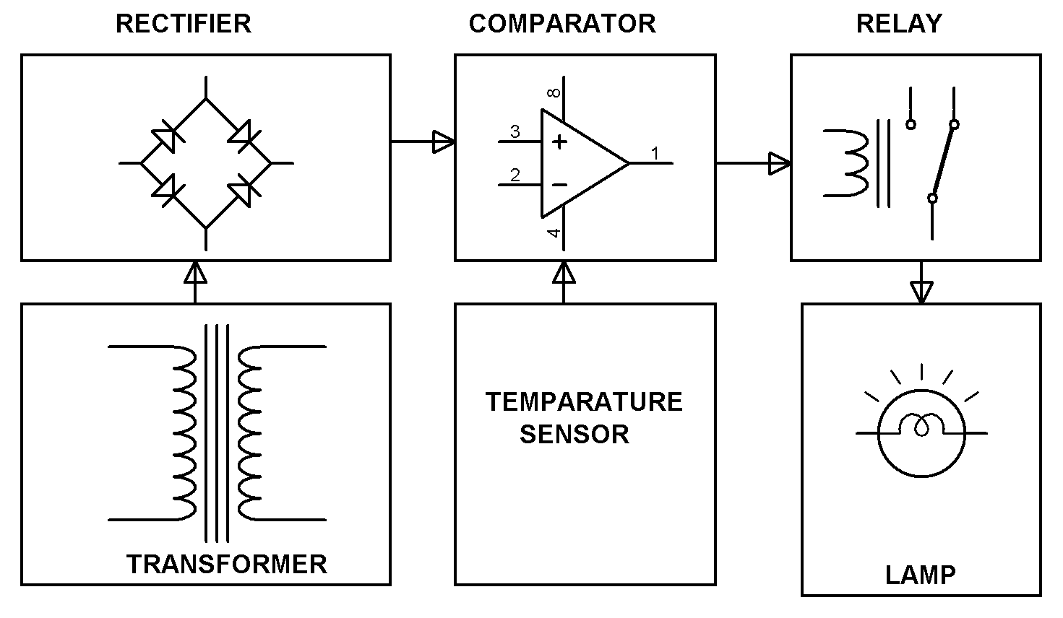

**HARDWARE REQUIREMENTS:**

THERMISTOR, COMPARATOR, TRANSISTOR, RELAY, LAMP.